January 17, 2015

Summary of Spindle PWM tests with tinyGv7

Test Platform
- tinyGv7 board with fw 438.02
  - tinyG PWMout 3.3V logic buffered to 5V with external 74AHCT125 driver
- Spindle Controller (see attachment)
- 400W DC spindle (see attachment)
- 24V Power Supply (tinyG VMot)
- 48V Power Supply (Spindle)
- Laser Tachometer for speed measurement.
- Hantek DSO 2090 for monitoring waveforms.

Summary
After numerous iterations, I settle on the following PWM parameters. I am only focused on CW parameters.
$p1
[p1frq] pwm frequency 2500 Hz
[p1csl] pwm cw speed lo 5500 RPM
[p1csh] pwm cw speed hi 12000 RPM
[p1cpl] pwm cw phase lo 0.080 [0..1]
[p1cph] pwm cw phase hi 0.900 [0..1]
[p1wsl] pwm ccw speed lo 1000 RPM
[p1wsh] pwm ccw speed hi 2000 RPM
[p1wpl] pwm ccw phase lo 0.125 [0..1]
[p1wph] pwm ccw phase hi 0.200 [0..1]
[p1pof] pwm phase off 0.000 [0..1]
tinyg [mm] ok>

Using the potentiometer on the PWM controller, I determined that the maximum no-load rotation is 11800 RPM. The operating frequency of the potentiometer controlled PWM oscillator is unknown at this time.

Test Method (Theses are all no-load [not cutting]) tests)
- Set a $p1frq value in the 1KHz to 10KHz range
  - (Note: a tinyG reset is required for the new p1frq to take affect.)
- Set a value of $p1pof in the range of 0.000 to 1.000
- Execute a Gcode M05 command, which reads the new value of $p1pof
- Measure spindle RPM
- Iterate 2-4 and record
- Modify $p1frq and re-run 2-5.

Observations (Phase a.k.a. PWM duty cycle)
- Unable to achieve 11700 RPM with p1frq above 2500Hz
  - Topped out around 10800RPM)
  - Results similar at $p1frq=1000 and 2500, motor whine at 1000Khz more noticable
- Spindle did run with $p1frq in the range of 50-20,000Hz , well beyond spec range.
- Spindle would not run above phase setting above 0.900 reliably
- Spindle would not run below phase setting below 0.080.
- With the selected settings above, spindle can be controlled from Gcode
  - “M03 S8000” turns on at 8000RPM with an interpolated phase setting.
  - “M03 S13000” same RPM as M03 S12000
  - “M03 S5000” same RPM as M03 S5500
    - Values $p1cpl and $p1cph set lower and upper bounds for PWM phase value.
    - TinyG accepts all(?) valid M03 Srpm commands, but limits low and high values.
To be Done
- Run similar test under load (cutting speed vs. no-load speed)

Attachment – CJM Controller and 400W Spindle Hardware

Spindle
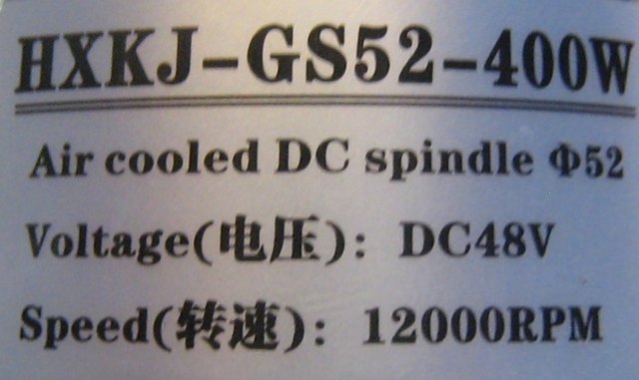
No other specs available
Purchased on Amazon

Controller

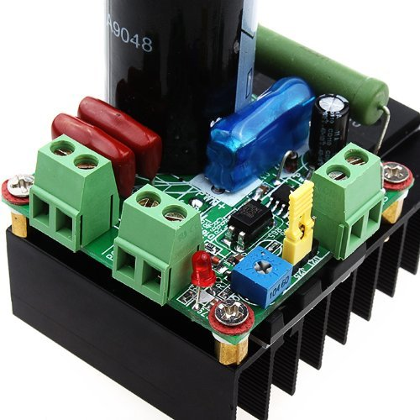
Amazon Link

Inventables Link

Product Description (from Amazon)
Features:
1.Can support AC and DC input. Non-existent power supply polarity problems.
2.Ultra-high voltage scope. support 12-160VDC Input. support 9-110VAC input.
3.Large radiator with mounting holes.
4.Ultra-high-power control. Max 10A current.
5.Except the board inside a PWM speed control, can also support an external PWM signal input speed control, external PWM input requirements: level 3.5-12V VPP, the frequency of 1K-10KHZ, in particular apply in MCH3 spindle speed control.
6. A wide range of support motor. Basic right into the letter drive of the market all the DC motor speed control. As long as the DC resistance of the motor is greater than 2 Ohms DC resistance can. Note in particular that this drive can not be less than the DC resistance of 2 Ohm DC motor speed control.
7.Equipped with a fuse protection and better performance.
8.The power indicator, and more convenient to use. Application:
Driven from 5V to 110V DC motor, DC motor speed control. Such as equipment of DC pumps, fans, engraving machine，spindle speed of the DC motor for precise control.

